43.59: 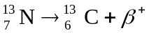 As in Problem 43.51, 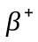decay has a mass defect in terms of neutral atoms of
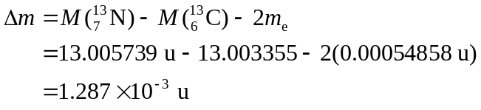
Therefore the decay is possible because the initial mass is greater than the final mass.

